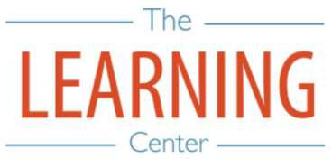
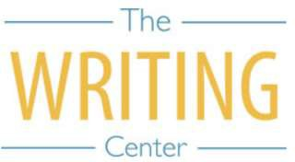
Spring Semester 2025

Sunday Monday Tuesday Wednesday Thursday Friday Saturday

5 JANUARY | 6 | 7 | 8 Classes begin | 9 | 10 | 11
12 | 13 | 14 | 15 | 16 | 17 | 18
19 | 20 Holiday (MLK Day) – No Classes | 21 | 22 | 23 | 24 | 25
26 | 27 | 28 | 29 | 30 | 31 | 1 FEBRUARY
2 | 3 | 4 | 5 | 6 | 7 | 8
9 | 10 Well-Being Day – No Classes | 11 Well-Being Day – No Classes | 12 | 13 | 14 | 15
16 | 17 | 18 | 19 | 20 | 21 | 22
23 | 24 | 25 | 26 | 27 | 28 | 1 MARCH
2 | 3 | 4 | 5 | 6 | 7 | 8 Spring Break
9 Spring Break | 10 Spring Break | 11 Spring Break | 12 Spring Break | 13 Spring Break | 14 Spring Break | 15 Spring Break
16 Spring Break | 17 Classes Resume | 18 | 19 | 20 | 21 | 22
23 | 24 | 25 | 26 | 27 | 28 | 29
30 | 31 | 1 APRIL | 2 | 3 | 4 | 5
6 | 7 | 8 | 9 | 10 | 11 | 12
13 | 14 | 15 | 16 | 17 Well-Being Day – No Classes | 18 Holiday – No Classes | 19
20 | 21 | 22 | 23 | 24 | 25 | 26
27 | 28 | 29 Classes end | 30 Reading Day | 1 MAY Exams | 2 Exams | 3 Reading Day
4 | 5 Exams | 6 Exams | 7 Reading Day | 8 Exams | 9 Exams | 10 Spring Commencement
11 | 12 | 13 | 14 | 15 | 16 | 17

The Writing & Learning Center / The University of North Carolina at Chapel Hill / writingcenter.unc.edu (919) 962-7710 learningcenter.unc.edu

