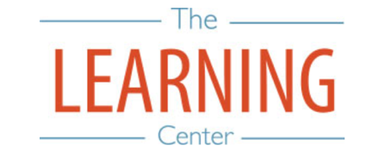
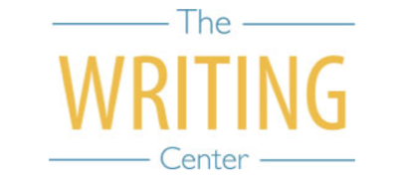

Fall Semester 2024

Sunday Monday Tuesday Wednesday Thursday Friday Saturday
4 AUGUST | 5 | 6 | 7 | 8 | 9 | 10
11 | 12 | 13 | 14 | 15 | 16 | 17
18 | 19 Classes Begin | 20 | 21 | 22 | 23 | 24
25 | 26 | 27 | 28 | 29 | 30 | 31
1 SEPTEMBER | 2 Holiday (Labor Day) – No Classes | 3 Well-Being Day – No Classes | 4 | 5 | 6 | 7
8 | 9 | 10 | 11 | 12 | 13 | 14
15 | 16 | 17 | 18 | 19 | 20 | 21
22 | 23 Well-Being Day – No Classes | 24 | 25 | 26 | 27 | 28
29 | 30 | 1 OCTOBER | 2 | 3 | 4 | 5
6 | 7 | 8 | 9 | 10 | 11 University Day (No classes held during ceremony) | 12
13 | 14 | 15 | 16 | 17 Fall Break | 18 Fall Break | 19 Fall Break
20 Fall Break | 21 | 22 | 23 | 24 | 25 | 26
27 | 28 | 29 | 30 | 31 | 1 NOVEMBER | 2
3 | 4 | 5 | 6 | 7 | 8 | 9
10 | 11 | 12 | 13 | 14 | 15 | 16
17 | 18 | 19 | 20 | 21 | 22 | 23
24 | 25 | 26 | 27 Thanksgiving Recess | 28 Thanksgiving Recess | 29 Thanksgiving Recess | 30 Thanksgiving Recess
1 DECEMBER Thanksgiving Recess | 2 | 3 | 4 Classes End | 5 Reading Day | 6 Exams | 7 Exams
8 | 9 Exams | 10 Exams | 11 Reading Day | 12 Exams | 13 Exams | 14

The Writing & Learning Center / The University of North Carolina at Chapel Hill / writingcenter.unc.edu / learningcenter.unc.edu

