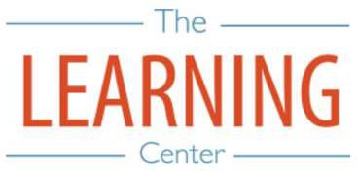
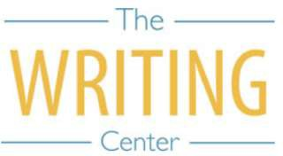
Spring Semester 2024

Sunday Monday Tuesday Wednesday Thursday Friday Saturday

7 JANUARY | 8 | 9 | 10 Classes begin | 11 | 12 | 13
14 | 15 Holiday (MLK Day) – No Classes | 16 | 17 | 18 | 19 | 20
21 | 22 | 23 | 24 | 25 | 26 | 27
28 | 29 | 30 | 31 | 1 FEBRUARY | 2 | 3
4 | 5 | 6 | 7 | 8 | 9 | 10
11 | 12 Well-Being Day – No Classes | 13 Well-Being Day – No Classes | 14 | 15 | 16 | 17
18 | 19 | 20 | 21 | 22 | 23 | 24
25 | 26 | 27 | 28 | 29 | 1 MARCH | 2
3 | 4 | 5 | 6 | 7 | 8 | 9 Spring Break
10 Spring Break | 11 Spring Break | 12 Spring Break | 13 Spring Break | 14 Spring Break | 15 Spring Break | 16 Spring Break
17 Spring Break | 18 Classes resume at 8AM | 19 | 20 | 21 | 22 | 23
24 | 25 | 26 | 27 | 28 Well-Being Day – No Classes | 29 Holiday – No Classes | 30
31 | 1 APRIL | 2 | 3 | 4 | 5 | 6
7 | 8 | 9 | 10 | 11 | 12 | 13
14 | 15 | 16 | 17 | 18 | 19 | 20
21 | 22 | 23 | 24 | 25 | 26 | 27
28 | 29 | 30 Classes end | 1 MAY Reading Day | 2 Exams | 3 Exams | 4 Reading Day
5 | 6 Exams | 7 Exams | 8 Reading Day | 9 Exams | 10 Exams | 11 Spring Commencement
12 | 13 | 14 | 15 | 16 | 17 | 18

The Writing & Learning Center / The University of North Carolina at Chapel Hill / writingcenter.unc.edu (919) 962-7710 learningcenter.unc.edu

